I installed that Oracle Virtual Box, Below is the screen shot.

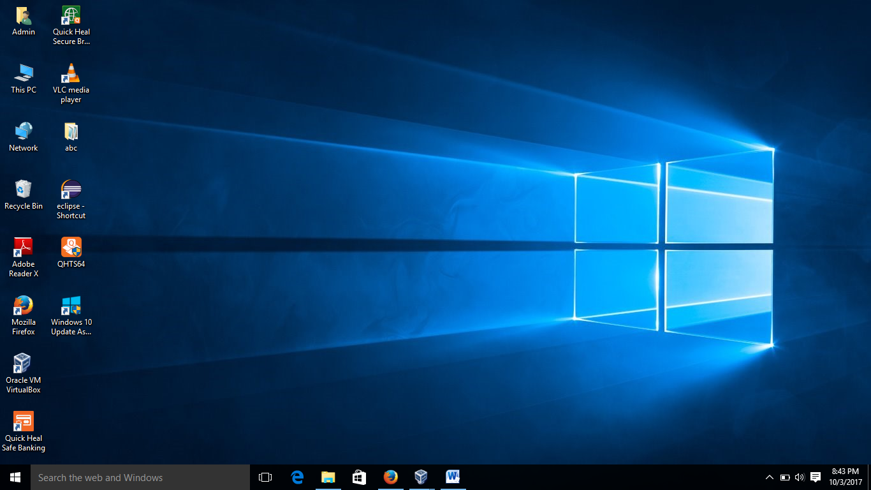

After importing that AcadgildVM on Oracle Virtual Box and started.

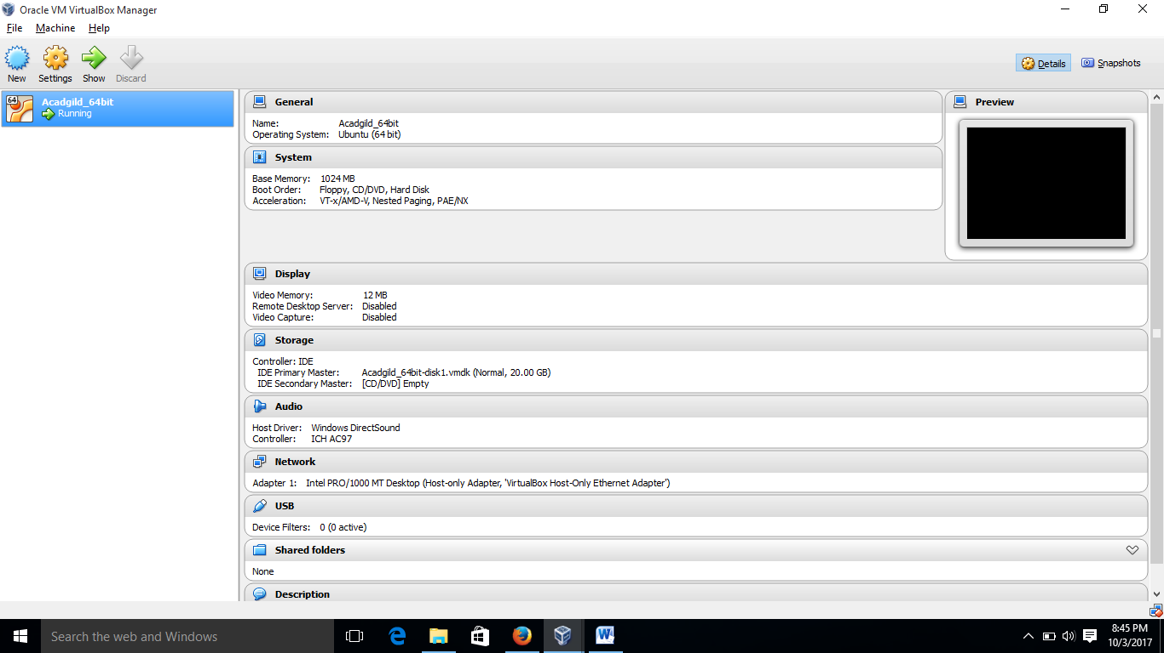

Below is the screen shot after login to our “AcadgildVM”.

